FRONTIERS OF Earth Science
K.L. Shrivastava and P.K. Shrivastava(Eds.)
Scientific Publisher (India),2015,120-135

THE MALANI SUPERCONTINENT

NARESH KOCHHAR
Centre of Advanced Study in Geology,
Panjab University, Chandigarh – 160014 INDIA
E-mail: nareshkochhar2003@yahoo.com

ABSTRACT

The plume related Malani magmatism in the NW Indian shield is intraplate, anorogenic, A-type and is indicative of extensional tectonic environment in the region. There is a relationship between mantle plume related anorogenic magmatism and assembly of a supercontinent. In this research paper similarities between TAB of NW Indian shield, Seychelles, Madagascar, Nubian-Arabian shield central Iran and South China constituting Malani supercontinent in terms of bimodal anorgenic magmatism, ring structures, Strutian glaciation and subsequent desiccation are discussed. Paleomagnetic data also support the existence of Malani Supercontinent

Key Words: Malani, Rajasthan, A-type granite, Supercontinent, Mantle Plume.

INTRODUCTION

The Indian subcontinent comprises three main geotectonically different blocks or terranes, the South Indian Block (SIB), the Bundelkhand Block (BB) and the Trans – Aravalli Block (TAB) which were juxtaposed and sutured during different periods of Earth’s history (Radhakrishna, 1989). The TAB and BB which are geologically unrelated to each other, are separated by NE-SW trending 700 km long Proterozoic Aravalli-Delhi mobile belt. The TAB and BB were sutured along Phulad lineament west of the Aravalli-Delhi orogen and the Great Boundary fault in the east prior to 2700-2500 Ma, the latter being the ages of cratonisation of Bundelkhand block (Ramakrishna and Vaidyanadhan, 2008) Gravity data indicates the Phulad lineament is a suture zone (Vijaya Rao and Tewari, 2008)

TRANS-ARAVALLI BLOCK

The TAB is unique in the geological evolution of the Indian shield as it marks a major period of anorogenic (A-type), ‘Within Plate’, high heat producing (HHP) magmatism represented by the Malani igneous suite of rocks (MIS). The Neoproterozoic Malani igneous suite (55,000 km²; 732 Ma) comprising peralkaline (Siwana), metaluminous to milidly peralkaline (Jalor), and peraluminous (Tusham and Jhunjhunu) granites with cogenetic carapace of acid volcanics (welded tuff, trachyte, rhyolite, explosion breccia and perlite) are characterized by volcano-plutonic ring structures and radial dykes. The suite is bimodal in nature with minor amounts of basalt, gabbro and dolerite dykes (Fig.1). The Siwana ring structure (30 km in EW 25 km in NS direction) is the most spectacular feature of the Thar desert. The representatives of Malani suite also occur at Kirana Hills, and at Nagar Parkar, Sindh, Pakistan (Qasim Jan et al., 1997). The Malani magmatism is controlled by NE-SW trending linements (zones of extension and high heat flow) of fundamental nature (mantle) and owes its origin to hot-spot and related tectonics. (Kochhar, 1973 for a review, Kochhar, 2000a).

SEISMIC, THERMAL AND CHEMICAL ANISOTROPY IN THE TAB.
1. Low velocity anomaly: Kennette and Widiwantoro (1999) based on P wave arrival time delineated a low velocity anomaly to the north of Cambay Gulf. This feature is 120 km across and is in marked contrast to high seismic velocities which characterize the lithosphere beneath the peninsular India. This anomaly extends from shallow depth to contact with more extensive low velocity zone below 200 km beneath the Indian lithosphere. The anomaly coincides with the Siwana ring structure, and the low velocity may represent the conduit of the fossil plume head, the Malani plume (Kochhar, 2001a, b) (Fig. 2)
2. Gravity and heat flow data: the Marwar terrain of the TAB is characterized by high heat flow and basement high (Krishna Brahmam. 1993, Mishra & Laxman, 1997). The Tusham area is associated with high heat flow of around 96 mWm⁻². The heat flow observed in and around Khetri and Jhunjhunu is 75 mWm⁻², with an average value of 60 mWm⁻² for the Delhi fold belt (Sunder et al., 1990).
3. Chemical and thermal anisotropy: The chemical and thermal anisotropy in the TAB is manifested in the anorogenic magmatism represented by high heat producing, A-type, ‘Within Plate’ Malani magmatism indicative of extensional tectonic environment, crustal thickness and high heat flow. The generation of A-type is controlled by thick crust, crustal extension with high heat flow (Pitcher, 1997). The bimodal nature of Malani magmatism as exemplified by the occurrence of basalt, gabbro and dolerite dykes of continental alkaline affinity, the trace element pattern of granite and the associated volcanic rocks (high abundance of HFS-Zr, NB, Ga, Zn, Y, REEs (except Eu) emphasis the role of halogens in fluxing these elements from the mantle (Kochhar et al., 1995, 2000a). The seismic, gravity, thermal and chemical anomalies in the TAB are symptomatic of plume activity in the region (Kochhar, 2000b)
REGIONAL GEOLOGY AND THE AGE OF MIS :

The lower boundary of the Malani rocks is exposed near Miniari, Pali district, Rajasthan where the Malani volcanics are underlain by the slates of Aravalli Supergroup, and in the Tusham area, Bhiwani district, Haryana, where the Malani volcanics are underlain by the Delhi quartzites, The upper boundary is observed at Radar hill, near Jodhpur Fort, where the Malani rhyolites are overlain by Jodhpur sandstone of Vindhyan age.

The Malani acid volcanics and the contemporaneous granites are much younger than the Aravalli-Delhi geosynclinal deposits with which they are associated at places. The time gap between the Delhi anorogenic and the emplacement of the MIS is 700 Ma, which is much more than the average span of an orogency (Condie, 1976, 2001). No direct relationship of the MIS with the Aravalli-Delhi cycles are observed in the field. Thus MIS is anorogenic and can not be related to any subduction process (Kochhar, 1998, 2004b).
Crawford and Compston (1970) determined an age of 745±10Ma (Rb/Sr method) for the Malani granites and rhyolites. Dhar et al., (1996) determined an age of 723±6Ma for the Malani granites and rhyolites. However, Crawford and Compston (1970) obtained a much younger age (428 Ma) for alleged Jalor granite (GA 1711), ‘a museum sample mistakenly attributed’. A rhyolite sample (GA 1734) also gave a young age of 526 Ma, but the ‘specimen in slightly weathered Ma’, and results may not be reliable (op cit.p.164).
These two doubtful specimens which have given younger ages were used by Srivastva (1988) to propose that Siwana and Jalor granites are much younger than the rhyolites and mark a thermal event at 500Ma related to a period of crustal up warping and rejuvenation before the commencement of Gondwana rifting. Sinha-Roy et al., (1998) also supported this view. Recently Rathore et al., (1999) on the basis of argon studies on two Jalor granite samples have arrived at a far fetched conclusion of 500-550Ma thermal event. According to the authors (op cit. p. 277, sample JR-15 is an altered sample, and Jr-17 also appears to be more radiogenic than other related samples. This was questioned by Kochhar (2001b) and Kochhar and Dhar, 2000 Torsvik et al., (2001) who opined that 500-550Ma age spectra were of poor quality with no statistically valid plateau. The dating of the Diri, Gurpratap Singh rocks of doubtful Malani affinity (Kochhar, 1998), at 779±10Ma by Rathore et al., (1996) led Roy (1999) to erroneously believe that the span of Malani rocks is about 100 Ma from 779 to 680 Ma. New U/Pb ages for Malani rhyolites range between 771±2 and 571±3Ma (unpublished data of Tucker et al., cited by Torsvic et al., 2001). The location of Tucker et al.,’s samples is not known.

GEOCHEMICAL CHARACTERISTICS OF THE MIS

The geochemistry (major, trace including rare earth elements) of the four complexes viz. Siwana, Jalor, Tusham and Jhunjhunu has been described in great details by Kochhar (1983, 1989a, 2000), Vallinayagam and Kochhar (1998), Kochhar and Dhar (1993) and Eby and Kochhar (1990), Sharma (1994), Pareek, (1981, 1984) Bhushan, (1995, 2000), Bhushan & Chandrasekran (2002). In the following paras geochemical signatures of Malani magmatism are given; which are indicative of A-type nature of MIS.

1. The granites are high level, sub volcanic and intrude their own ejecta.

2. They are characterized by volcano-plutonic ring structures and radial dykes. They occur in anorogenic setting i.e. ‘Within Plate’ tectonic environment.

3. The Siwana and Jalor magmatism show biomodal suite of granites, trachytes, rhyolites and basalt (gabbro, dolerite).

4. They are felsic, peralkaline (Siwana), metaluminous (Jalor) and peraluminous (Tusham and Jhunjhunu). The Malani granites plot in the alkali granite field of QAP diagram.

5. The Siwana granites are hypersolvus, whereas the Tusham and Jhunjhunu granite are peraluminous. The Jalor granites are mainly subsolvus but have a hypersolvus component closely associated with them in space and time. (Kochhar and Dhar, 1993 Garhia and Ravi, 1995)

6. These granites are low in CaO, MgO, high in silica, Na₂O + K₂O, Fe/Mg, Zr, Hf, Nb, Ta, high REEs (except Eu) and low in Sc, Cr, Co, Ni, Ba, Sr and Eu abundance.

7. According to Whalen et al., (1987) high Ga/Al ratio is an effective discriminator of A-type granitoids and other granite types. The Ga/Al versus Zr plot for the Malani granites, the Siwana, Jalor and Tusham granites from distinct clusters putside M–, I–, and S-type granites. They fall in the A-type field. The field of Seychelles granites overlaps with that of Jalor and Tusham granites (Fig. 3). For discriminating highly fractionated I-type granites, similar relationship can be seen in a plot of Ga/Al versus Zr+Nb+Ce+Y. The Jhunjhunu granites grade from highly fractioned I-type granites to A-type granites (Fig. 4), Ga behaves as incompatible element in A-type suites (Eby, 1990).
Eby (1992) has classified A-type granites into two subdividions: Al granties which have Y/Nb and Yb/Ta ratios less than 1.2, and the A2 granites which have this ratio between 1.2-7. the A1-type granites have generally low initial Sr ratios, and these are differentiates of basaltic magma directly derived from oceanie-island basalt (OIB) like mantle source which may have undergone some crustal interaction. These granites ere emplaced during intraplate rifting or as the result of inferred plume or hot-spot activity. The A2 granites have highly variable initial Sr. ratios and this groups exhibits complex petrogenetic history. Some suites have significant mantle component, whereas the others may be of crustal origin. The A2 group granites represent magmas derived from continental crust or under plated crust that has been through a cycle of continent-continent collision or island are magmatism. These granites were emplaced at the end of a long period of apparently high heat flow and granitic magmatism.

The Y/Nb and Yb/Ta plot of Siwana, Tusham and Jhunjhunu indicate the Jhunjhunu granites cluster around OIB, whereas, the Siwana and Tusham granites plot between the average crust and IAB. The dispersion of measured values away from the source towards continental crust may be indicative of crustal interaction in their petrogenesis (Fig. 5). It is important to mention here that Y/Nb and Yb/Ta ratios are measure of amphibole and pyroxene fractionation in the evolution of magma and can change if the crust interacts with the magma. The crustal involvement (Y/Nb and Yb/Ta ratios: 2 or more) can push A₁ granite to A2 granite field.

8. Siwana granites are characterized by high total REE content relatively flat chondrite normalized pattern with little fractionation between LREE and HREE (La/Yb=2.3), with marked Eu anomaly (Eu/Eu*=0.34).They develop a relative enrichment in middle REE group (Sm, Gd and Dy) with corresponding Eu depletion characteristics REE pattern of peralkaline granites (Kochhar, 1989b) (Fig. 6). The relative enrichment of MREE may be related to the precipitation of early formed perthitic feldspar and late crystallization of alkali amphiboles from low temperature liquid enriched in volatiles (Bowden and Whitley, 1974). Tusham granites fall in a very restricted range of REE abundances and the LREE are enriched with respect to HREE (LA/Yb=17) and show moderate Eu anomaly with Eu/Eu* = 0.44. Jalor granites have the lowest REE abundances with La/Yb ratios of 5. The REE pattern of subsolvus granites (biotite granite) is quite different from that of hypersolvus (alkali) granite. The La/Yb ratios for subsolvus granites and hypersolvus granites are 1.52 to 2.55 and 2.61 to 4.27 respectively. There in moderate LREE enrichment and a mild upward curvature of HREE portion of the chondrite-normalized plot ( Fig. 7). The hypersolvus granites show enrichment of LREE as compared to subsolvus granites (Fig. 8). In the subsolvus granties, Eu anomaly is more pronounced (Eu/Eu*=0.15) as compared to hypersolvus granites (Eu/Eu*.41). Normally peralkaline (hypersolvus) granites show more prounced Eu anomaly (cf. Bowden and Kinnaird, 1984; Vallinayagam and Kochhar, 1998) as compared to the subsolvus granites. The more prounced Eu anomaly in the subsolvus granites could be due to the interaction with a fluid phase and also due to fractionation of plagioclase (Kochhar and Dhar, 1993). Like the the Jalor granites, the perlkaline granites of the Median Mountains, Saudi Arabia (Harris and Mariner, 1980) also show enrichment of LREE with less marked Eu anomaly as compared to peraluminous granites.

9. Jhunjhunu granites are also characterized by a relatively flat chondrite-noramalized pattern with slight enrichment of LREE (La/Yb=9) and with marked Eu anomaly (Eu/Eu*=0.25) (Kochhar and Sharma, 1992) (Fig. 9).

10. The Malani granites are of high heat production type, (Kochhar, 1989a). These granites have potential of Sn-W-Rare metal mineralization (Kochhar, 1985, 1989c, Sharma, 1994). The average heat productivities are as follows: Jhunjhunu granites: 13.06 μwm⁻³, Tusham granites: 7.68 μwm⁻³, Siwana granites: 5.90 μwm⁻³, Jalor granites : 2.80 μwm⁻³.

11. Amphiboles and Pyroxenes : The amphiboles in the alkali granites evolve from richterite to arfvedsonite (magmatic subsolidus trend), in trachyte from arfvedsonite to riebeckite (oxidizing), and in rhyolite from richterite through arfvedsonite to riebeckite (magmatic subsoliduous to oxidizing trend). The pyroxens in the alkali granites evolve from hedenbergite to aegirine through aegirine augite, (acmite hedenbergite trend) whereas in the acid volcanics they are represented by aegirine (acmite trend) Arfvedsonite and aegirine also occur as needles in gabbro (Baskar and Kochhar, 1995, Vallinayagam, 1997 Mukherjee and Roy, 1981, Bhushan, 1995) have also shown erichment of Ti, Fe, Na and depetion of Ca, Mg and K in aegirine of Siwana granite. The trace element studies along with morphological studies indicate that the Tusham zircons belong to hydrothermal and late magmatic type. The high content of UO₂ in the zircons is a reflection of high abundances of UO₂ in the host rocks, Jalor zircons are magmatic. The Siwana granites though high in Zr values have very poor zircons yield due to peralkalinity of the Siwana magama (Kochhar et al, 1991).

12. Biotites : The biotites from Jalor, Tusham and Jhunjhunu granites show iron enrichment trend. FeO⁺/MgO ratio is the highest (6.72) in Jalor granites, whereas lower values of (4.08) and (3.72) have been observed in Tusham and Jhunjhjunu samples respectively. Mg Fe and 2AI 3Fe⁺² substitution is dominant in Jalor samples, whereas influence of 3Mg Al is deciphered in the Tusham and Jhunjhunu samples (Dhar et al., 2002).

13. Basic Rocks: EPMA studies indicate that augite and aegirine are the main pyroxenes in the basalts and gabbros, whereas arfvedsonite is the dominant amphibole is these rocks. The chemistry of amphiboles and pyroxenes indicate that they have high contents of Na and Fe and low contents of Mg and Ca thereby indicating alkalie nature of Siwana parental magma (Vallinayagam, 1997).

14. The Siwana granites (10 samples) show an ubiquitous low ¹⁸O values(-0.10 to + 1.8%_{o}) with respect to SMOW, whereas the Jalor granites (10 samples) also show low values (-4.60 to + 1.2%). These low values are indicative of interaction with low ¹⁸O rift related meteoric/hydrothermal systems generated by cylindrical shaped Siwana granites of HHP nature which acted as ‘steam engines’. The Tusham and Jhunjhunu granite show values which range 16.4 to 11.6% and 5.9 to 8.9 % respectively indicating no significant hydrothermal interaction with low º18 find (Kochhar, 2000a).

PETROGENESIS:

The trace elements including REE data show that Siwana granites are likely to be derived as a high temperature melt from anhydrous granites source from which a previous melt has been extracted. The Jalor granites are more primitive and have a more fractionated REE pattern but may have been derived from a similar source. The Tusham granite show chemical characteristics typical of magma derived from a high grade metasedimentary source. The Jhunjhunu granites appear to have been derived from a source of granodirite composition (Eby and Kochhar, 1990, Kochhar, 2000). Pb and Nd isotopic compositions show that Siwana magma is mantle derived and for Jalor complex combined Sr, Pb and Nd data indicate primary mantle derivation will a variable degree of crustal contamination with the assimilated crust of Archean age (Kochhar, 2000a). The data also document the presence of Archean rocks in the region (Dhar et al., 1996) (Vallinayagam and Kochhar, 2009).

The commonality between widely separated Tusham, Jhunjhunu, Siwana and Jalor complex is anorogenic, ‘within plate’ magmatism, characterized by ring structure and extensional tectonic environment during the same thermal regime in the TAB of the NW Indian shield gone 732 Ma age.

Malani Supercontinent:
There is a relationship between mantle plume related anorogenic magmatism and assembly of a supercontinent. Plumes initiate continental break up by doming and rifting and rupturing (Morgan, 1972). Preceding Pangaea (Late Paleozoic Supercontinent) was the supercontinent of Rodinia generally regarded as persisting to the latest Proterozoic but with wide uncertainities concerning its configuration and times of assembly and dispersal (Rogers et al., 1993). According to Dalziel (1992) breaking up of Rodinia occurred during two phases one at 750 Ma and the younger rifting phase at 550 Ma. The breakup at 750 Ma resulted in the separation of East Gondwana from the present west coast of Laurentia.

Spot paleomagentic readings at 750 Ma also suggest that neither India nor Australia can be joined in either a traditional East Gondwana or Rodinia fit. The data also does not support the idea of coherent East Gondwana (Meert, 2001). Anekt-Mozambique ocean closed to form Arabian – Nubian shield – the join between East and West Gondwana during 870-640 Ma (Unrug, 1992, Rogers et al., 1993).

The period ca. 732 Ma B.P. mark a major Pan-African tectono-magmatic event of widespread magmatism of alkali granites and comagmatic acid volcanics (anorogenic, A-type) in the Trans – Aravalli block of the Indian shield, central Iran (Forster, 1987), Nubian – Arabian shield (Kroner et al., 1989) and Madagascar and South China (Yoshida et al., 1999) (Kochhar, 2007a,), (Li et al., 1999, 2004), Somalia (Kroner et al., 1990) and Seychelles (Hoshino, 1986) (Kochhar, 2004 a,b), Central Iran (Nadimi, 2007) (Sankaran, 2003).

In view of the widespread ca. 750 Ma alkaline magmatism, which is so widespread, and well developed in the TAB, central Iran, Arabian-Nubian shield, Madagascar and S. China, Somalia, , Seychelles, Kochhar (1996, 2000a,b, 2001, 2007, 2008a,b,c,2009) proposed that all these micocontinents were characterized by a common crustal stress pattern, rifting and thermal regime, Strutian glaciation and dessication and similar paleolatitudinal positions which could be attributed to the existence of a supercontinent – the Malani Supercontinent, (Table 1) (Fig. 10).

Table – 1
Similarities between TAB, Nubian Arabian Shield, Seychelles, and South China in terms of bimodal, anorogenic magmatism, protolith, paleopoles and Strutian glaciation and subsequent desiccation.

 | TAB  NW INDIAN  SHIELD | SEYCHELLES | NUBIAN-ARABIAN SHIELD | S. CHINA YANGTZE BLOCK
Alkali Magmatism granites | Siwana Jalor Tusham ca 745 Ma | Mahe, Ste Anna Praslin  ca. 700-755 Ma | Jabal-Al Hasasin Jabal-AS Sawal Dahul  ca. 700-760 Ma | Chengjian  ca. 780-745Ma
Protolith | Archean  BGC | Archean  BGC | Paleo Proterozoic or older crustal Precursor | --
Paleopole | 55-70ºN | 30ºN | -- | 70ºN
Strutian glaciation | Pokhran, Salt Range Boulder Bed | -- | Haqf  Super Group | Linntua and Nantua deposits
Evaporite/ Carbonate Sequence | Hanseran, Nagaur – Bikaner Basin | -- | Hormuz Series | Late Sinian Late Precambrian carbonates and phosphates.

Seychelles: The Mahe (750Ma) and Ste. Anne (764 Ma) granties of Seychelles have been correlated with 732Ma old hypersolvus (Siwana) and subsolvus (Jalor granites) of MIS. These granites have A-type signatures and owe their origin to the same protolith of Archean crust of (amphibolite) BGC of Rajasthan as indicated by Sm. Nd; Rb/Sr isotopic data. The Seychlles and Malani granites have similar low oxygen isotope ratios δ18 ‰ SMOW (+3 to +4% (Seychelles granites) and (Siwana and Jalor grnatie) ( –0.10 to +1.8:10, -4.60 to +1.2: ‰ ) (Ashwal et al., 2002, Kochhar, 2004).

SIMILARITIES BETWEEN GRANITES OF MIS (JALOR AND SIWANA) AND THE SEYCHELLES (MAHE, STE. ANNE AND PRASLIN) GRANITES: (Kochhar, 2004)

- The coeval (730 Ma) (Rb/Sr) hypersolvus (Siwana) and subsolvus (Jalor) granites of MIS (Kochhar and Dhar, 1993) have been correlated with Mahe (750 Ma) and Ste. Anne (764Ma) granites of Seychelles (Ashwal et al., 2002).
- Role or Archean basement granitic complex crust (2.5-2.2 Ga) in the evolution of granites of both the regions. Pb and Nd isotopic compositions of the Siwana granites show that the magma is mantle derived, and for Jalor complex, the combined Sr and Nd data indicate primary mantle derivatives with a variable degree of contamination crust of Archean age (Dhar et al., 1996). According to Ashwal et al., (2002) the Archean crust of BGC Rajasthan, 3.2 Ga of amphibolitic composition with initial Sr and Nd isotopic composition at 750 Ma could be suitable source of Mahe granitic rocks of Seychelles.
- Tectonic discrimination diagrams: Ga/Al vs. Zr plot of Mahe and Praslin granites indicate A-type affinity, and the data overlap with the fields of Jalor and Tusham granites of MIS (c.f. Fig.3). Similarly majority of Seychelles samples plot in the WPG field of Ta vs. Yb and Nb vs. Y diagrams of Pearce et al., (1984). It is surprising that Ashwal et al., (2002) did not plot these tectonic discriminating diagrams.
- Oxygen isotopic data: The Seychelles granites are characterized by low 18₀ (+3 to +4) %_{o} as compared to +5 to +11 %_{o} values of most terrestrial igneous rocks. This corresponds well with the low 18₀ values of +1.0 to 1.8%_{o} of Siwana granites and –4.0 to 1.21 values of Jalor granites (Kochhar, 2000a).
Torsvic et al., (2001) obtained a paleomagnetic pole with latitude 74.5 N and longitude 71.2E at 750 Ma for the MIS, whereas, Klootwijk (1975) had obatiend 81S latitude and 22.4E longitude for MIS at 729 Ma. Paleomagnetic data place the MIS at 41N at local paleolatitude when combined with normal polarity site of Klootwijk (1975) and the Seychelles at 30N (Torsvic et al., 2001). At 750 Ma B.P Seychelles and MIS were only 600km apart. Since the ‘Within Plate’, anorogenic nature and extensional tectonic environment of MIS is established, its correlation with Mahe, Praslin and Ste. Anne granites is suggestive of similar setting for the Seychelles granites. Stephens et al., (1997) also favour intraplate, extensional tectonic environment for Seychelles granites which could be related to the plume tectonics. The MIS does not represent Andean type arc on the western margin of Rodinia.

Madagascar: Within central block of Madagascar carion granites which have alkaline geochemical signatures and are post tectonic were emplaced during extensional collapse of Pan-African Orogen (Kroner et al., 1998) U/Pb ages of granites of western central Madagascar near Ambistra indicate emplacement age of 804-775 Ma, some of these granites have gabberoic rocks as sleeves (Handke et al., 1999). In this respect they are very much similar to Jalor granites. According to Cox et al., (2004) the central Madagasar was a part of Congo-Sao Fransico craton at ca 1800 Ma but became the independent terrane during Rodinia time and joined India by ca 700 Ma.

According to Collins and Windley (1997) the Antananarvio block of Central Madagascar, a broad band of pre-1000Ma continental crust that streteches from Yemen through Somalia and Eastern Ethiopia into Madagascar is sandwiched between two suture zone. This crust is caught up in the East African orogen and bound on east and west by juvenile post-1000 Ma Arabian-Nubian rocks and oceanic suture zones.

The Arabian Shield :
The Arabian Nubian shield (ANS) is an accreted terrane composed of crustal domains of island arc, oceanic and continental affinities overlain by post accretionary sediments and volcanics, and invaded by voluminous intrusions. The Saudi Arabia part of the Nubian-Arabian shield has been divided into five terranes separated by four suture zones. The three terranes i.e. Asir, Hijaz, Midyan west of the Nabitah suture zone are of ensiamatic character, whereas, eastern two i.e. Afif and Ar-Rayan are of continental to marginal continental character. The three ensiamatic terranes are collectively referred to Arabian-Nubian arc terranes (Stoeser, 1986).

Most of the shield was created in two distinct stages. These are (1) Island arc stage (between 660-900 Ma) in which subduction related processes operated for the generation of magma, and (2) a post accretionary stage (between 550-700 Ma) where magma was generated by fusion of continental protolith (Stoeser, 1986). According to Jackson (1986) the post accretionary stage is marked by the presence of granitic intrusions. According to Stern (2004) the evolution of the Arabian-Nubian shield occurred between 870 Ma and the end of Precambrian (ca.542Ma) and the crustal growth encompassed a time of dramatic climatic change (see below).

The Late Proterozoic history of ANS can be limited into three distinct evolutionary phases (1) the rise of Pan-African, plume head that led to enriched plume model, oceanic plateau and oceanic crust. (2) Calc-alkaline magmatism in island arc activity (between 870 and 650 Ma) which resulted in mafic crust and lithospheric mantle, (3) The melting of mafic crust and lithospheric mantle resulted into formation of alkali granite and basalts between 650-530 Ma (Stein, 2003)

In southern Yemen, the amalgamation of the two terranes ie. Abas (west) and Al-Mahfid (east), separated by Al Bayda island arc sequence, is marked by the 760 Ma magmatic activity (Whitehouse et al., 2004). According to Johnson and Kattan (2004) the Asir terrane is more closely linked structurally and tectonically with East African orogen, Madagascar, Ethiopia, Somalia, Yemen and Eritea than with the northern Shield, and that the southern and northern Arabian shields may be decoupled.

The remnant of the Archean crust as Proterozoic basement has been reported on the basis of lead isotope studies in the Afif terrane. A zircon from trondjhemite along the Al Amar fault has yielded 2067±74 Ma age there by indicating Late Proterozoic crust in the shield. Granodiorite gneiss from Jabal Khida in the easternmost part of the shield has been dated at 1629± 20 Ma (Stoeser, 1986).

According to Stoeser et al., (2004) there is no indication of crust formation between 1670-900 Ma as indicated by U/Pb and single zircon data. Between 760-740 Ma ago, the Khida terrane separated from the margin of Paleoproterozoic and Archean continetal block-the Arabian craton, presently concealed beneath the Phanerozoic cover in the east but exposed in Yemen.

Magmatism:
The Arabian shield contains one of the largest fields of alkali granites in the world. Forty nine major and more than a dozen minor alkali granite plutons occur in the Midyan and Hijaz terranes and in the Nabitah orogenic belt. The alkali granites do not occur SW and easternmost part of the shield. The alkali granites were the last intrusive phase and were emplaced during a span of 180 Ma between 680-510 Ma ago. The alkali granites are spatially associated with metaluminous hypersolvus to subsolvus granites, the latter forming the core of complexes. The alkali granies are also associated with a swarm of alkali rhyolite dykes in the northeastern part of the shield (Stoeser and Ellion, 1985). A total of thirty three ring complexes and funnel shaped intrusions have been recognized related to the extensional tectonic regime in the Arabian shield. (Fig. 11, Table-2) The magmatism (670-570 Ma) is mainly peralkaline to metaluminous with A-type affinity. The granites and the related rock types were emplaced by cauldron subsidence which operated in the final stage of the cratonisation of the Arabian shield (Roobal and White, 1986). The Katharina ring complex (Sinai peninsular, Gabel Musa) is one of the most representative Late Pan-African ring complexs in the Arabian – Nubian shield. Along with a number of A-type granitic plutons, it was formed in the Late stage of shield evolution at about 600 Ma. The complex has low ⁸⁷Sr/ ⁸⁶Sr ratios (0.702-0.703) and postive ªNd (t) value indicating juvenile character. The granitic magma was delivered by partial melting of juvenile rocks and differentiation of mantle derived magma Granilic rocks from other parts of ANS consistently show positive ªNd(T) values which give evidence of juvenile crust and high rate of crustal growth (Stein, 202, Jahn, 2008). Interestingly, the central Asian Orogenic Belt (CAOB) also show growth of massive Juvenile crust in many terrenes such as Mongolia, Altai-Xinjiang, Inner Mongolia, NE China, Trans-Baikalia, Kazakstan and West Sayan and Gorny Altal of S. Siberia. The juvenile crust was formed by vertical accretion of non-orogenic granitoids and their volcanic equivalents, and also by lateral accretion of arc assemblages (Jahn, 2004). In this respect the evolution of TAB crust and (Jalor and Siwana granites of MIS with positve ªNd(T) values) is very much similar to ANS and CAOB terranes. In southern Israel (northern parts of ANS Late Pan-African dyke swarm of basic to acid composition were emplaced during 600 to 530 Ma. Similar dykes occur in Sinai Peninsula and eastern desert of Egypt. These dykes are post orgenic within plate, are enriched in alkalis, LILE and HFSE, Sr, Nd isotopic data indicate impact of juvenile crust in the geneses.

The peraluminous and peralkaline granites with A-type geochemical characteristics are encountered at Jabal-Al Hasasin, Jabal As Sawal Jabal Dahul (Stoeser et. al., 2004). According to Vail and Kuron (1978) high level ring complexes, ring dykes and cone sheets have been reported from the Red Sea Hills and Bayuda desert in NE Sudan. These complexes comprise granites, quartz syenite, nepheline syenite gabbro etc have been dated at 700 Ma. The Abas terrane is dominated by 760 Ma granitoids, (Whitehouse et. al., 2004). with Sm-Nd model ages (2.3 Ga) indicating reworking of a Paleoproterozoic or older crustal precursor. These features are very much similar to the Siwana and Jalor granites of MIS (Kochhar, 2009)

CENTRAL IRAN
Interestingly Forster (1987) compared the Infra-Cambrian and Cambrian rhyolites and the associated granites of Central Iran with the Malani rhyolites and the Pan-African granites of Arabian shield. The similarity has been attributed to the Gondwana connection based on paleomagnetic data. Central Iran held a position south of equator during Infra Cambrian and later drifted from the southern margin of the Gondwanaland to its present position as a micro plate. According to Kroner et. al., 1990, the period between 850-750 Ma represents the most significant crust formation event in all parts of ANS including Somalia in the form of felsic intraplate magmatism. Rogers (1990) has also suggested that both Indian shield and Arabian Nubian shields are similar in their development including production of alkali granites, subsidence of thick partly deformed basin on recently formed crust and ultimate development of plateformal cover sediments.

According to Nademi (2007) the Late Neo Proterozoic proto-Gondwanaland assembly, central Iran terrain fits a gap of significant width between the Western India (Salt Range) and the eastern Arabian (Oman margin), This is borne out by the stratigraphy and paleomagnetic data. The extensional tectonic regime during Late Neoproterozoic began with granitic intrusions and alkali volcanics (alkali rhyolite, tiff, quartz porphyry, the Gharadash Formation in NW Iran, the Taxnar Formation in the Kashmar region, NE Iran and Esfqrdi Formation in SE Iran and the Harmuz Formation in Zagros. This wide spread post orogenic magmatism indicate extensional tectonic environment (Pan-African event). Following Pan-African orogeny, the Precambrian creation of Iran, Pakistan, Afganistan, SE Turkey and Arabia became a relatively stable continental platform with epicontinental shelf deposits (mainly clastic). There was lack of major magmatism or folding subsequently.

Similarities between the Trans-Aravalli Block (TAB) and the Arabian Nubian shield (ANS) (Kochhar, 2008b, 2008c, 2009).

1. Both the terranes are characterized by the occurrence of alkali granites (peraluminous-peralkaline with A-type geochemical signatures) at 732 Ma and ca. 700 Ma respectively.
2. The emplacement of these granites and the associated acid volcanics was controlled by ring structures and cauldron subsidence. Ring complexes are the continental manifestations of plume activity and are indicative of extensional tectonic environment.
3. Both the terranes preserve the remnants of Archean crust i.e. BGC of amphibolitic facies (3.2 Ga in the TAB (Kochhar, 2004, 2008b) and trondjhemite of 2.6 Ga in the Afif terrane of ANS. This older crustal protolith has acted as precursor to the younger alkali granites.
4. Both the terranes show positive ªNd (T) values for granites (Siwana and Jalor granites of TAB) indicating Juvenile character. The hot-spot (mantle plume) magmatism played an important role in the formation of juvenile crust. The rising plume causes upwelling event, underplating there by replenishes the uppermost mantle by incompatible trace elements (Kochhar, 1984, Kochhar et al., 1995). Stein (2003) termed such replenished mantle as plume mantle.
5. In both the terranes the alkali granites mark the cratonisation of the shield.
6. Both the terranes are characterized by similar peralkaline and peraluminous granite hosted mineralization of U, Th, Nb, Ta REEs, Sn, W, Li and F etc. In this respect they are akin to the younger granites of Nigeria. (Kochhar, 1998, 2000, 2009 and Vallinayagam, 1999, Somani 2006, 2009).
7. Both the terranes are characterized by the occurrence of evaporites-carbonate sequence and show evidence of Strutian glaciation.

The aforesaid similarities can only be explained if the Arabian Nubian shield was attached to the Trans-Aravalli block of the Indian shield around 600-700 Ma B.P. in the configuration of the Malani Supercontinent.

South China: South China comprises the Yangtze Craton (YC) to the northeast and the Precambrian Cathysia block to the southeast. The YC has a Late Archaean–Proterozoic nucleus surrounded mostly by younger orogenic belts. Both the blocks were sutured during collision of Grenville age. Neoproterozoic anorogenic magmatism and coeval mafic magmatism are widespread around the YC of South China. The magmatism coincides with NS-trending Kangdian rift and NE-trending Nanhua rift. The first one at ca. 830–795 Ma (prerift) and the second one at 780–745 Ma (syn-rift), the Chengjian magmatism. The later granites are younger than 1.0 Ga Siban orogeny and intrude the rift sequence. Both the pre- and syn-rift magmatism have been attributed to superplume because of its intraplate setting, peralkaline to alkaline affinity and association with coeval swarms of mafic dykes. Emplacement of the dyke swarm initiated the break-up of Rodinia. The super plume may represent two normal plumes to account for these two episodes of magmatism6. According to Wong and Li (2001), at places the ca. 780–750 Ma granites are uncomfortably overlain by Upper Sinian sequence (750 Ma), which is interpreted to have formed a rift cover. Li et al. (2004) have correlated the syn-rift (780–745 Ma) magmatism with the Malani magmatism besides those of Laurentia, South Africa and Australia.

Paleomagmatism and Strutian glaciation:
The APWP palaeomagnetic poles at ca. 800 Ma place South China at 55–70N at par with high paleolatitudes of India during Malani rhyolite period (ca. 750 Ma) (Li at al., 2004, Torsvic et al., 2001). The migration of India to higher paleolatitudes could be the cause of Precambrian glaciation as exemplified by the Pokhran boulder in Rajasthan which is of glaciogenic origin (Chauhan et al., 2001) (Pareek, 1984) (Sinha-Roy et al., 1998). Incidentally, the Pokhran diamicitite correlates with other Precambrian diamictites in the Lesser Himalaya such as Blaini boulder bed, Manjir and Bhimdasa in Jammu and Kashmir, Tankaki in Hazara, and Buxa Group (Shergaon pebbled bed) in Arunachal Pradesh (Valdiya, 1995, Virdi, 1995, Tawari, 2005). Interestingly, Bose et al.1997 have reported acid pyroclastics such as welded tuff, ash flow tuff, lapilli tuff, volcanic clasts from the Late Proterozoic formations of Lesser Himalaya, viz. Shimla Group, Blaini Formation, Infrakrol Formation and the Krol Group. The source of these pyroclastics could be attributed to the nearby Tusham acid volcanics of Malani age. It is possible that the precursor to the Lesser Himalyan terrane was a contiguous part of the TAB during Late Proterozoic. The boulders of Malani granites also occur in the Salt Range. In the YC, Liantua and Nantua (748 Ma) deposits are of glaciogenic origin8. Around 700 Ma BP India started drifting towards the tropical latitudes and around 600 Ma, India was near the equator15. According to Pooranchandra Rao et al., (1997) there has been large polar movement between the Malani rhyolite and other lower Cambrian period poles indicating rapid migration of the Indian subcontinent from the northern to southern hemisphere latitudes. During this period, the northern margins of India were subjected to desiccation. The carbonate, mainly dolomite and phosphate deposits of Late Sinian–Late Precambrian age in Yangtze block, corresponds with Hanseran evaporites in the Marwar basin of TAB, SW Punjab, and Bilara phosphorites in Rajasthan.

The carbonate evaporite facies of the Hauq Supergroup form a belt of evaporite basin and intervening carbonate platform which can be traced in these microcontinents:Hormuz Series of Arabian Gulf and southern Iran, Infra -Cambrian carbonate plateform in Central Iran, Ghabar Group of South Yemen, India Ad Series of Somalia, Wadi Fatima Series and Abla Formation, South Arabia Saramuj Formation of Jordan, Salt Range Formation, Pakistan, and evaporites of Nagaur-Bikaner basin and subsurface evaporite and anhydrite sequence of SW Punjab and Haryana, India (Fig.12) (Gorgin et. al., 1982, Kochhar, 2004, 2008). The Huaqf axis formed a barrier between evaporites and carbonate platform and or anhydrite plateform. The Oman-Ural magalineamnet controlled the distribution of evaporite-carbonate sequence.

Recently, Singh et al., (2006) have described Neoproterozoic evaporite sequence from Lesser Himalaya comprising gypsum and anhydrite, gypsum + carbonate, and halite from the Kashmir sub-basin (Ramban, Assar belt), and Chamba subbasin (Bathri) respectively, and halite from the Guma-Drang area of Mandi, Himachal Pradesh. According to Illyin 1990, the continental margins of Vendian–Early Precambrian supercontinent comprising South China, Kazakhstan, Mongolia and proto-Tethys were the sites of equatorial sedimentation in the form of shallow water carbonate and phosphorite deposits. A short-lived positive excursion in carbon isotope values noticed at phosphorite level in the Birmania (Upper Carbonate) Formation in the TAB and in the basal part of Tal Group in Krol basin is also known from Dahal member of the Yuhucun Formation of Meishucunian zone-II ( Kumar et al., 1997). According to Pandit et al.(2001), extremely low C13 values in the Bilaria carbonate indicate glacial-related cold climatic conditions, while positive shift in the carbon isotope values in the upper formations implies a warmer climatic condition. The Bilara carbonate group carbon isotope profile have close correspondence with global carbon isotopic evolution curve in Haqf, Oman, Siberia, platform, Mongolia and Morocco and elsewhere. Li et al.(2004) have proposed A 90^{O} spin of Rodinia that brought the entire supercontinent into equatorial latitudes. The spin was the result of initiation of a subequatorial superplume by ca. 750 Ma. The spin corresponds with reversal of geomagnetic field during the deposition of each group of Vindhyan Supergroup, i.e. Kaimur, Rewa and Bhandar. During the Kaimur period (1400–750 Ma) there have been at least three reversals of geomagnetic field (Pooranchandra Rao et al., 1997). The combined 800–700 Ma apparent polar wander path implies pole-toequator rapid velocities of 20 cm/yr for India and South China, which is unlike the other continents such as Australia and Congo. (Kochhar 2001) suggested that since the Indian subplate is a mosaic of three major tectonostratigraphic blocks with different magmatic and metamorphic histories, the position of India in the assembly of a Late Proterozoic supercontinent should not be viewed as a single entity. For example, the southern tip of the SIB (south of Palaghat Cauvery shear zone), Sri Lanka and Madagascar along with the Eastern Antarctica formed a supercontinent (Idnurm and Radhakrishna, 1999). In other supercontinent assembly Meghalaya lies SW of Yilgarn craton of Australia, Bungar hills and Wind Mill Islands in an Antarctican contimation of Frazer moloile belt. Due to similarities of bimodal, anorogenic magmatism in South China, India and Australia, Li et al., (2003) have suggested that the superplume was responsible for the break-up of supercontinent during Neoproterozoic. The Malani plume was responsible for the separation of TAB from East Gondwana. The Malani plume may be the present day position of subequatorial plume at 750 Ma BP proposed by Li et al.(2004) (Figure 13). In view of the occurrence of widespread bimodal, anorogenic plume-related magmatism, Strutian glaciation and similar palaeolatitude position, the YC of South China fits well in the reconstruction of the Malani supercontinent. The position of South China between Australia and Laurentia is debatable because of an alternate equatorial Rodinia supercontinent, excluding high-latitude cratons in India and South China(Li et al., 2003). According to Ye et al., 2007 orogeneses, plutonism and ophiolite obsduciton in the Sibaoan arc is related to ocean closure between the Yangtze Cathaysian block implying that Rodinia was not completely assembled, until 0.9Ga. This raises doubts about the missing link South china model (c.f. Li et al., 2008).Whether the Precambrian glaciation in India and South China was due to the flight of these terranes to high latitudes during the Malani rhyolite period or the glaciation was of low latitude due to increased CO2 drawdown and global albedo affected by waning of plume volcanism is debatable (Kilner et al., 2005). The evidences presented here support the idea of polar Strutian glaciation in the TAB and Lesser Himalayan terrane due to plume tectonics.

Acknowledgements

Earlier versions of this paper were presented at the 33rd IGC, Oslo, August 2008 in the session HPP-04: From Rodinia to Nuno and beyond, and in the session ASI-04: Evolution of the Arabian-Jubian shield and its Orogenesis; at the International Conference on Tectonics of Indian Subcontinent, Indian Institute of Technology Bombay. 2009; and at Asia-Oceania Geoscience Society Meeting 2009 at Singapore. I thank Drs. Z.X. Li, Bor-Ming Jahn, A. Davidson, Ali T. Al-Mishwat and Dr. D Stoeser for their helpful comments.

REFERENCES

Ashwal, L.D., Demaiffe, and Torsvic, J., 2002, Petrogenesis of Neoproterozoic granitoids and related rocks from the Seychelles, the case for an Andean-type arc origin. J. Pet., v. 43, no. 1, pp. 45-84.
Banerjee, D.M., and Mazumdar, A., 1999, On the Late Neoproterozoic- Early Cambrian trasition events in part of east Gondwanaland. Gond. Res., v. 2, pp. 199-211.
Baskar, R., and Kochhar, N., 1995, Peralkaline granites and associated acid volcanics of the Siwana ring structure, Rajasthan, India: some mineralogical constraints for magma peralkalinity. Proc. Second South Asia Geological Congress (GEOSAS), Colombo, Srilanka, p. 221.
Bhushan, S.K. 1989. Mineral chemistry and petrographic aspects of Malani volcanic, W. Rajasthan. Ind. Mineral. V. 43, pp. 325-338.\
Bhushan, S.K., 1995, Late Proterozoic continental growth implications from geochemistry of acid magmatism events of west Indian craton. Geol. Soc. Ind. Mem., 34, pp. 339-356.
Bhushan, S.K., 2000. Neoproterozoic magmatism of the Malani igneous suite, W. Rajasthan, India. Geol. Surv. Ind. Spl. Pub. No. 55, pp. 319-332.
Bhushan, S.K., and Chandrasekran, v., 2002, Geology and geochemistry of the magmatic rocks of the Malani igneous suite and Tertiary volcanics province of W. Rajasthan. Geol. Surv. Ind. Mem.126, 181p.
Bonin, B., 2007. A-type granites and related rocks: evolution of a concept, problems and prospects. Lithos, v. 97, no.1,2, pp1-29
Bose, U., Nagal, S.C., Sharma, N.L., Prashra, K.C., Sharma, V.K. and Bassi, U.K., 1997. Pyroclastice in the Late Proterozoic formation of the Simla Himalaya, Jr. Geol. Soc. Ind. V. 49, pp. 539-545.
Bowden, P., and Whitley, J.E., 1974, Rare earth pattern in peralkaline and associated granites. Lithos, v. 7, pp. 15-21.
Chauhan, D.S., Mathur, K.M., Narayan Ram, 2001, Geological nature of the Pokaran Boulder Bed : Paleoenvironmental, paleoclimatic and stratigraphic implication Jr. Geol. Soc. Ind. v. 58, pp. 425-433.
Collins, A.S. and Windley, B.F. 2002, The tectonic evolution of Central and Northern Madagascar and its place in the final assembly of Gondwana. Jr. Geol. v. 110, pp. 325-339.
Condie, K.C., 1976. Plate tectonics and crustal evoluation. Pergamon Press, Toronto, 288p.
Condie, K.C., 2001. Mantle plumes and their record in earth history. Cambridge University Press, Cambridge, p. 306.
Cox, R., Coleman, D.S., Chokel, C.B., Doreo, B., and Kroner, A., 2004 Proterozoic tectonostratigraphy and paleogeography of central Madagascar derived from detrital zircons – U/Pb age population Jr. Geol. v. 112, pp. 379-399.
Crawford, A.R. and Compston, W., 1970, The age of Vindhyan system of peninsular India. Quart. Jour. Geol. Soc. London, v. 175, pp. 351-370.
Crawford, A.R., 1970, The Precambrian geochronology of Rajasthan and Bundelkhand, northern India. Can. J. Earth Sci. v. 7, pp-91-110.
Dalziel, L.W.D., 1992 on the organisation of American plate in the Neoproteroazoic and the breakout of Laurentia. . GSA Today v.2 pp. 237-241.
Dhar, S., Frei, R., Kramer, J.N.D., Nagles, T.F., and Kochhar, N., 1996, Sr., Pb and Nd isotope studies and their bearing on the petrogenesis of Jalor and Siwana complexes, Rajasthan, India. Jr. Geol. Soc. Ind., v. 48, pp. 151-160.
Dhar, S., Kochhar, N., and Gupta, L.N. 2002, Mineral chemistry of biotites from Jalor, Tusham and Jhunfhunu ring complexes, Malani ignious suite, India. Jr. Geol. Soc. Ind. v 60, pp. 567-571.
Eby, G.N., 1990, The A-type granitoids : A review of the occurrences and chemicak characteristics and speculation on their petrogenesis. Lithos, v. 26, pp. 115-134.
Eby, G.N., 1992, Chemical subdivisions of the A-type granitoids : Petrogenetic and tectonic implications. Geology, v. 20, pp. 641-644.
Eby, G.N., and Kochhar, N., 1990, Geochemistry and petrogenesis of the Malani igneous suite, northern India. Jr. Geol. Soc. Ind., v. 36, pp. 109-130.
Forster, H., 1987, Ignimbrite cauldrons, alkali granites and mineral deposits in fault block mountains. Geol. Rundsch., v. 76/2, pp. 373-388.
Garhia, S.S., and Ravi, L., 1995, Study of sirohi granitoids around Jaswantpura,Jalor dist. Rajasthan Rec. Geol. Surv. Ind., v. 127, pp. 15,17
Gorin, G.E., Racz, L.G; and Walter, M.R, 1982, Late Precambrian-Cambrian sediments of Hugf Group. Sultanate of Oman. AAPG Bull. V. 68, pp.2609-2627.
Harris, N.B.W., and Mariner, G.F., 1980, Geochemistry and petrogenesis of a peralkaline granite complex from the Midian Mountains, Saudi Arabia. Lithos, v. 13, pp. 225-337.
Hoshimo, M., 1986, Amphiboles and coexisiting ferromagnesian silicates in granitic rocks in Mahe, Seychelles. Lithos, v. 9, pp. 11-21.
Idnurm, M. and Radhakrishna, T., 1999, Australia and Indian Proterozoic APWPS and time of amalgamation. Geol. Soc. Ind. Mem. v. 44, pp. 33-44.
Ilyin, A.V. 1990. Proterozoic super continent, its lastest Precambrina rifting, breakup, dispersal into smaller continents and subsidence of their margin: Evidence from Asia Geology, v. 18, pp. 1231-1238
Ilyin, A.V., 1990, Proterozoic supercontinent, its latest Precambrian rifting, breakup, dispersal into smaller continents and subsidence of their margins: Evidence from Asia Geology, v. 18, pp. 1231-1235.
Jackson, N.J., 1986, Petrogenesis and evolution of Arabian felsic plutonic rocks, Jr. African Earth Sci., v. 4, pp.47-50.
Jahn, B.M., 2004, The Central Asia Orogenic Belt and growth of the continental crust in the Phanerozoic In. Malpas, J. et al., ed.) Aspects of the tectonic evolution of China. Geol. Soc. Lon. Spl. Pub. 226, pp. 73-100.
Jahn, B.M., 2008 Accretionary orgenic and growth of the continental crust from Neoproterozoic to recent : Nd-Sr isotopic evidence IAGR conference Seminar 5, pp. 19-21.
Kennett, B.L.M. and Widiywantro, S., 1999, A low velocity wavespeed anomaly beneath northwestern India: A seismic signature of the Deccan plume? Earth Planet Sci. Lett., v. 165, No. 1, pp. 145-156.
Kilner, B., Macniocaill; and Brasier, M., 2005, Low latitude glaciation in the Neoproterozoic of Oman. Geology v. 33, pp. 413-416.
Kochhar, N., 1973, Indo-Gangetic basin, ring structures and continental drift Nature, v. 242, p. 141-142.
Kochhar, N., 1983, Tusham ringh complex, Bhiwani, India. Proc. Indian natn. Sci. Acad., v. 49A, pp. 459-490.
Kochhar, N., 1985, Malani igneous suite : Porphyry copper and tin deposits from the Tusham ring complex, north peninsular India. Geol. Zbornic-Geol. Carpathica, v. 36, No. 3, pp. 245-255.
Kochhar, N., 1989a High heat producing granities of the Malani igneous suite, northern peninsular India. Indian Minerals, v. 43, pp. 339-346.
Kochhar, N., 1989b Malani igneous suite : A-type magmatism in the north peninsular India. Proc. 29th IGC, Washington, D.C., USA, v. 2/2, pp. 203-204.
Kochhar, N., 1989c, Rare-metal potential of the A-type Malani granites, northwestern peninsular India. Indian Minerfal, v. 53, pp. 271-276.
Kochhar, N., 1996. 750 Ma supercontinent : evidence from the Indian shield. Special symp. F-9. The break –up accretion of the Asia continent 30th IGC, Beijing, China, p. 255
Kochhar, N., 1998 Malani igneous suite of rocks. Correspondence, Jr. Geol. Soc. Ind., v. 51, p. 126.
Kochhar, N. 2000a, Attributes and significance of the A-type Malani magmatism, northwestern peninsular India. In M. Deb (Ed.) Crustal Evolution and Metallogeny in the northwestern Indian shield, Chapter 9, pp. 183-217, Narosa Publishing house, New Delhi.
Kochhar, N., 2000b, Mantle plume, anorgenic magmatism and supercontinent Proc. Workshop on Plume Tectonics, NGRI, Hydrabad, pp. 20-24.
Kochhar, N., 2001a, Anorogenic magmatism, mantle plume and assembly of the Late Proterozoic Malani supercontinent, NW Indian shield. International Symp. Assembly and breakup of Rodinia and Gondwana, and Growth of Asia, GRG/GIGE Misc. Publ. No. 12, pp. 22-27.
Kochhar, N., 2001b. Signatures and significance of the Pan-African thermo-tectonic event in the Indian subcontinent. Bull. Ind. Geol. Assoc. v. 34, pp. 36-42.`
Kochhar, N., 2004a. Geological evoluation of the Trans-Aravalli, block, (TAB) of the NW Indian Shield constraints from the Malani supercontinent and the Seychelles connection during Late Proterozoic. Scientific session , abstract part 2, p. 870, 32nd IGC, Florence, Italy.
Kochhar, N., 2004b, Geological evolution of the Trans-Aravalli block (TAB) of the NW Indian Shield and Seychelles connection in the Late Proterozoic : evidence from plume related A-type Malani magmatism. Geol. Surv.Ind. Spl. Pub. No. 84, pp. 247-264.
Kochhar, N., 2007. Was Yangtze Craton South China attached to the Trans-Aravalli Block of the NW Indian Shield during Late Proterozoic ? Current Science, v. 92, pp. 295-297.
Kochhar, N., 2008a. A-type Malani magmatism NW Peninsular India. In A.K. Singhvi, A. Bhattacharya and S. Guha (Eds.) Glimpses of geosciences research in India. The Indian Report to IUGS2004-2008. Indian National Science Academy, New Dlehi, pp. 176-181.
Kochhar, N., 2008b. A-type Malani magmatism: Signaturer of the Pan-African event in NW Indian Shield and the assembly of a Late Proterozoic Malani supercontinent. Geol. Surv. Ind. Spl. Pub.v. 91, pp.112-126.
Kochhar, N., 2008c. Geochemical signature of the A- type Malani magmatism, NW peninsular India and assembly of the Late Proterozoic Malani supercontinent. Geol. Soc. Ind. Mem. no. 4., pp. 21-36.
Kochhar, N., 2009. The Malani supercontinet: Middle East connection during Late Proterozoic In. Shrivastva (ed.) Economic Mineralisation Scientific Publishers(India) Jodhpur, pp. 15-25.
Kochhar, N., and Dhar, S., 1993, The association of hypersolvus-subsolvus granites : A study of Malani igneous suite, India. Jr. Geol. Soc. Ind., v. 42, pp. 449-467.
Kochhar, N., and Sharma, R., 1992. A-type granites of Jhunjhunu area, dist. Jhunjhunu, north peninsular India, Abstr. 29th IGC, Kyoto, Japan, p. 578.
Kochhar, N., Dhar, S., and Sharma, R., 1995, Geochemistry and tectonic significance of acid and basic dykes associated with Jalor magmatism, West Rajasthan. Geol. Soc. Ind. Mem. 33, pp. 375-389.
Kochhar, N., Vallinayagam, G. and Gupta, L.N., 1991. Zircons from the granitic rocks of the Malani igneous suite : morphological and chemial studies. Jour. Geol. Soc. Ind. v. 38, pp. 561-576.
Kroner, A., Eyal., M., and Eyal, Y., 1990, Eartly Pan-African evolution of the basement around Elat, Isreal, and the Sinai peninsul revealed by single zircon evaportion dating, and implications for crustal accretion rate. Geology, v. 18, pp. 545-548.
Kroner, A., Reischmann, T., Tojt, Y., Zimmer, M., Stern, R.J., Hussein, U., Mansour, M., Eyal, M., Eyal., Y., and Sassi, P. (1989) Timing mechanism and geochemical pattern of arc accretion in the Arabian-Nubian shield and its extension into Isreal and Somalia. Extended Abstr. 28th IGC, Washington, DC, USA, v. 2, p. 2/231.
Kumar, G., Shanker, R., Maithy, P.K., Mathur, V.K., Bhattacharya, S.K., and Jani, R.A., (1997). Terminal Proterozoic-Cambrian sequences in India: a review with special reference to Precambrian-Cambrian boundary. Paleobot., v. 46, pp.19-33.
Li, Z.X., and 16 others, 2008. Assembly configuration , and breakup history of Rodinia: A synthesis. Precamb. Res. v. 160, pp. 179-210.
Li, Z.X., Evans, D.A.D., and Zhang, S., 2004. A 90º spin on Rodinia: possible casual links between the Neoproterozoic supercontinent. super plume, true polar wander and low latitude glaciation. Earth Planet Sci. Lett., v. 220, pp. 409-421.
Li, Z.X., Li, X.H., Kinny P.D., Wang, J. Zhang, S., Zhu, H., 2003, Geochronology of Neo-proterozoic syn-rift magmatism in the Yangtze craton, sourth China and correlation with other continents: evidence for a mantle super-plume that broke up Rodinia. Precamb. Res., v. 122, pp. 85-109.
Li, Z.X., Li, X.H., Kinny, P.D., and Wang, J., 1999, The breakup of Rodinia, Did it start with a mantle plume beneath south China. Earth Planet. Sci. Lett., v. 173, pp. 171-181.
Mishra, D.C., and Laxman, G., 1997, Some major tectonic elements of western Ganga basin based on analyses of Bouger anamoly map, Curr. Sci. v. 73, pp. 436-440.
Morgan, W.S. 1972. Deep mantle convection plumes and plate tectonics. AAPG, Bull. V. 58, pp. 203-213.
Mukherjee, A.B. and Roy, A., 1981, Cooling condition of the high level Precambrian granites of Siwana: evidence of experimental melting relation behavior and the sodic amphibole-ryloxene. Ind. J. Earth Sci. V. 8, pp. 99-108.
Nadimi, A., 2007. Evolution of central Iranian basement, Gondwana Res., v. 12, pp. 324-333.
Paliwal, B.S., and Rathore, P.S., 2000, Neoproterozoic volcanics and sedimentaries of Jodhpur, A reappraisal In K.C. Gyani and P.Kataria (Eds.) Tectonomagmatism, geochemistry and metamorphism of Precambrian terrain University Press, Udaipur, pp. 75-96.
Pandit, M.K., Ashwal, L.D., Tucker, R.D., Carter, L.M., Van Lante, B., Torsvic, T.H., Jamtveit, B., and Bhushan, S.K., 2001, Proterozoic acid magmatism in the northwest Indian shield and its significance for Rodinia construction, Gondwana Res. v. 4, pp. 726-728.
Pareek, H.S., 1981, Petrochemistry and petrogenesis of the Malani igneous suite, India, Geol. Soc. Am. Bull., v. 93, 926-928.
Pareek, H.S., 1984, Pre-Quaternary geology and mineral resources of northwestern Rajasthan, India, Mem. Geol.Surv. Ind., v. 115, 116p.
Pearce, J.A., Harris, N.B.W. and Tindle, A.G. 1984. Trace element discrimenation diagram for the tectonic interpretation of granitic rocks. Jr. Pet. v. 25, pp. 956-983.
Pitcher, W.S., 1997, The nature and origin of granites. Chapman and Hall, London, 387p..
Powell, C.Mc A., Li, Z.X., McElihiney, M.W., Meert, J.G. and Park, J.K., 1993, Paleomagnetic constraints on timing of the Neoproterozoic breakup of Rodinia and the Cambrian formation of Gondwana geology, v.2, pp. 889-892.
Qasim Jan, M., Lachari, A., and Asif Khan, M., 1997, Petrography of the Nagar Parkar igneous complex, Tharparkar, SE Sindh Geol. Bull. Univ. Peshwar, v. 30, 227-249.
Radhakrishna, B.P., 1989, Suspect tectono-stratigraphic terrane elements in the Indian subcontinent. Jr. Geol. Soc. Ind., v. 34, pp. 1-24.
Ramakrishana, M. and Vaidyanadham, R., 2008, Geology of India, volume. 1, Geological Society of India, Publicaiton 556p.
Ramsay, C.R., 1986, Specialized felsic plutonic rocks of the Arabian shield and their precursors. Jr. African Earth Sci. v.4, pp. 153-168.
Vijayarao., and Tewari, H.C., 2008. Deep crustal seismic studies over the Indian shield . In A.K. Singhvi, A. Bhattacharya and S. Guha (eds.) Glimpses of geoscience research in India, The Indian Report to IUGS, 2004-2008. INSA, New Delhi Publication, pp. 137-143.
Rathore, S.S. Venketesh, T.R. and Srivastva, R.K., 1999, Rb/Sr dating of Neoproterozoic (Malani Group)magmatism from SW Rajasthan, India. Evidence of younger Pan-African event by 40_{Ar}/ 39_{Ar} studies. Gondwana Res., v. 2, pp. 271-281.
Rogers, J.J.W., 1990, Comparison of India and Nubian shield. In S.M.Naqvi (Ed.) Precambrian continental crust and its economic resources. Development in Precambrian Geology, 6, Elsevier, New York.
Roobal, M.J. and White, D.L., 1986, Cauldron subsidence and calderon above Arabian felsic plutons : a preliminary survey. Jr. African Earth Sci. v. 4, pp.123-134.
Roy, A.B. 1999, Neoproterozoic crustal evolution and India-Gondwana linkage-An Epilogue. Gond. Res. v. 2, pp. 193-198.
Sankaran, A.V., 2003. The supercontinent medley : recent views. Curr. Sci., v. 85, pp. 1121-1124.
Sharma, Rajni, 1994, High heat production (HHP) granites of Jhunjhunu area, Rajasthan, India. Bull. Ind. Geol. Assoc. v. 27, pp. 55-61.
Singh B.P., Singh S.P. and Sachan, H., 2006. Post depositional transformation during burial and exhumation in the Neoproterozoic evaporite sequence NW Himalaya. India. Jr. Geol. Soc. Ind. V. 68, pp. 1058-1068.
Sinha-Roy, S., Malhotra, G., and Mohanty, M., 1998, Geology of Rajasthan, Geol. Soc. Ind. Publ. Bangalore. 278p.
Somani, R.L., 2006, Evolution of the tin-tungston and copper-bearing hydrothermal solutions associated with Tusham igneous compelx, Bhiwani, Haryana: a fluid inclusion study. Jr. Geol. Soc. Ind., v.67, pp.379-386.
Srivastva, R.K. 1988. Magmatism in the Aravalli Mountain range and its enuirons. Geol. Soc. Ind. Mem. 7, pp. 78-93.
Stephens, W.E., Jemielita, R.A. and Davies, D. 1997, Evidence for ca 750 Ma intraplate extensional tectonics for granite magmatism from the Seychelles: new geochronological data and implications for Rodinia reconstruction and fragmentation . Terra. Nova, v. 9, p. 166.
Stern, R., Avigad, D. Beyth, M., Gebresilassie, S., Kuster, D., Mehare, K., and Miller, N., 2004, The Neoproterozoic Snowball earth hypothesis and the Arabian – Nubian shield, 32nd IGC, Florence, Italy, Scientific sessions : Abstract (part2), p.1191.
Stoeser, D., Whitehouse, M., and Stacey, J., 2004, Neoproterozoic evolution of the Khida terrane: Saudi Arabia : A detached microplate of the Arabian Shield, 32nd IGC, Florence, Italy, Scientific sessions : Abstract (part2), p1190.
Stoeser, D.B. 1986, Distribution and tectonic setting of plutonic rocks of the Arabian shield .Jr. African Earth Sci. v. 4, pp.21-46.
Stoeser, D.B. and Elliott, J.E., 1985, Reconnaissance geology of the Al-Qasr Quadringle, sheet 27/41C Kingdom of Saudi Arabia, Open file Report – USGS-OF-05/2, Scale 1:100,000
Sundar, A., Gupta, M.L. and Sharma, S.R., 1998, Heat flow in the Trans-Aravalli suite, Tusham India. Jr. Geodyn. v. 12, pp. 89-100.
Tewari, V.C., 2003, Sedimentology, paleobiology and stable isotope chemostratigraphy of the terminal Neoproterozoic Buxa dolomite, Arunachal Pradesh, NE Lesser Himalaya, Him. Geol. v. 24, pp.1-18.
Thomson, P.R., and Kattan, F.N., 2004, Geochemistry and structural reappraisal of the Asir terrane assembly, S. Arabia Shield, 32nd IGC, Florence, Italy, Scientific sessions : Abstract (part2), p1190.
Torsvic, T.H. Ashwal, L.D. Tucker, R.D. Elde, E.A. 2001 – Neoproterozoic geo-chronology and paleogeogrpahy of the Seychelles microcontinent: The India Link Precambrian Res. v. 110, pp. 47-57.
Torsvic, T.H., Carter, I.M., Ashwal, L.D. and Bhushan, S.K. Pandit, M.K. and L.D. Jamtveit, B., 2001. Rodinia refined or obscured : paleomagnetism of the Malani igneous suite, N.W. India Precamb. Res., v. 108, pp. 319-333.
Unrug, R. 1992. The supercontinent cycle and Gondwana and assembly: component cratons and the timing of suturing events J. Geodyn. L. 16, pp. 215-240.
Vail, J.R. and Kuron, J.L., 1978, High level igneous emplacement in the Red Sea Hills, Sudan Geol. Runds. v. 67, pp. 521-530
Valdiya, K.S., 1995, Proterozoic sedimentation and Pan-African geodynamic development in the Himalaya. Precamb. Res. v. 76, pp. 35-55.
Vallinayagam, G. and Kochhar, 2009, Petrological evolution and emplacement of Siwana and Jalor ring complexes of Malani igneous suite: NW peneinsular India. In topics in Igneous Petrology: A tribute to Prof. Mikhi K. Bose. Springer . pp. (in press)
Vallinayagam, G., 1997, Mineral chemistry of the Siwana ring structure complex, Rajasthan, India. Indian Mineralogist, v. 31, pp. 37-47.
Vallinayagam, G., 1999. Nb, Zr, REE-rich Geid rock from piplun area of Siwana ring complex, w. Rajasthan, India. In Geological evolution of north western India, B.S. Paliwal (Ed.) Scientific publishers, Jodhpur, 94-102
Vallinayagam, G., and Kochhar, N. 1998, Geochemical characterization of A-type granites and the associated acid volcanics of Siwana ring complex, north peninsular India. In B.S. Paliwal (Ed.) The Indian Precambrian, Scientific Publishers, Jodhipur, pp. 462-481.
Virdi, N.S., 1999, Co-existing Late Proterozoic glacigene sediments and evaporites in theLesser Himalaya and eastern Indian shield –expression of contemporaneity of low latitude glaciation and tropical dessication. In B.S. Paliwal (Ed.) The Indian Precambrian, Scientific Publishers, Jodhpur, pp. 502-511.
Wang, J., and Li, Z.X., 2001. Sequence stratigraphy and evolution of the Neoproterozoic marginal basins, along south eastern Yangtze cration. Gond. Res. v. 4, p. 17-26.
Whitehouse, M., Flowerdew, M., Windley, B., Al-Khirbash, S., and Ba-Bttat, M., 2004, The Al Bayda arc, Yemen : A 200 Ma record of Neopertoerozoic accretion at the eastern margin of the Arabina-Nubian shield. 32nd IGC, Florence, Italy, Scientific sessions : Abstract (part2), p1190.
Ye, M-F., Li, X. H., Li, W.X., Liu, Y. and Li, Z.X., 2007. SHRIMP Zircon U-Pb geochronological and whole rock geochemical evidence for the early Sibaoan magmatic are along the SE margin of the Yangtze block. Gond. Res. v. 12, pp. 144-156.
Yoshida, M., Rajesh, H.M., and Santosh, M., 1999, Juxtaposition of India and Madagascar : a perspective, Gond. Res. v. 2, pp. 449-467.

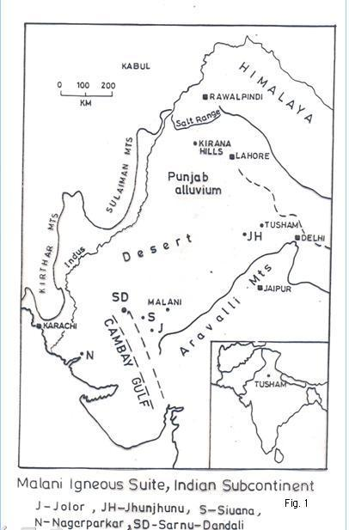

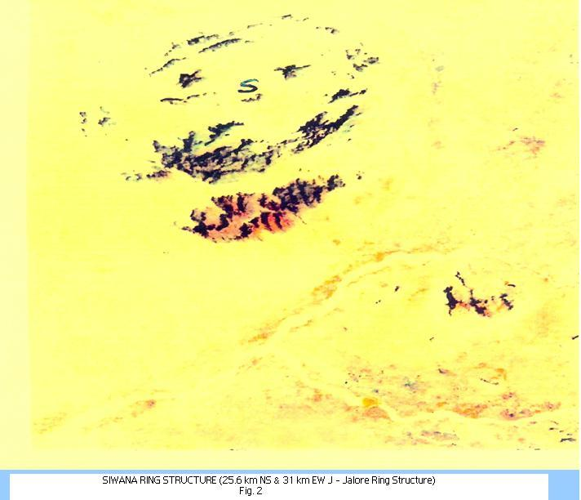

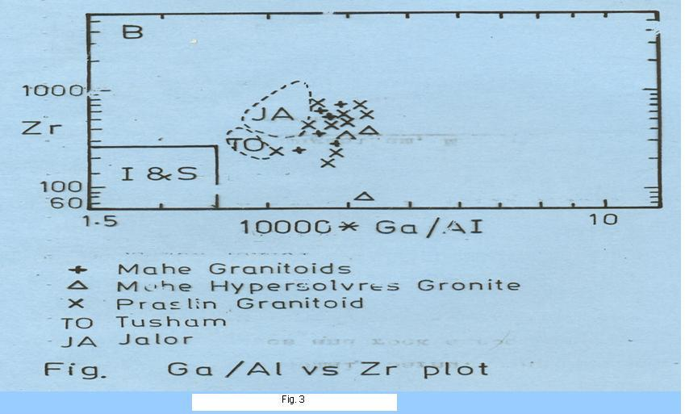

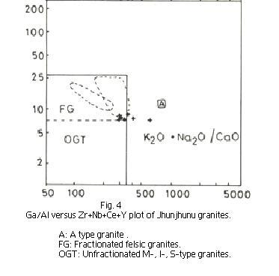
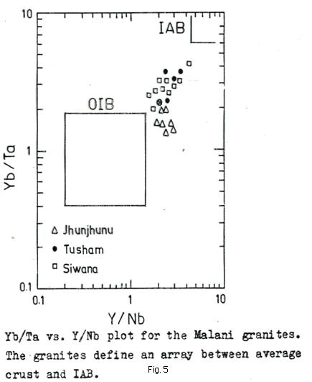

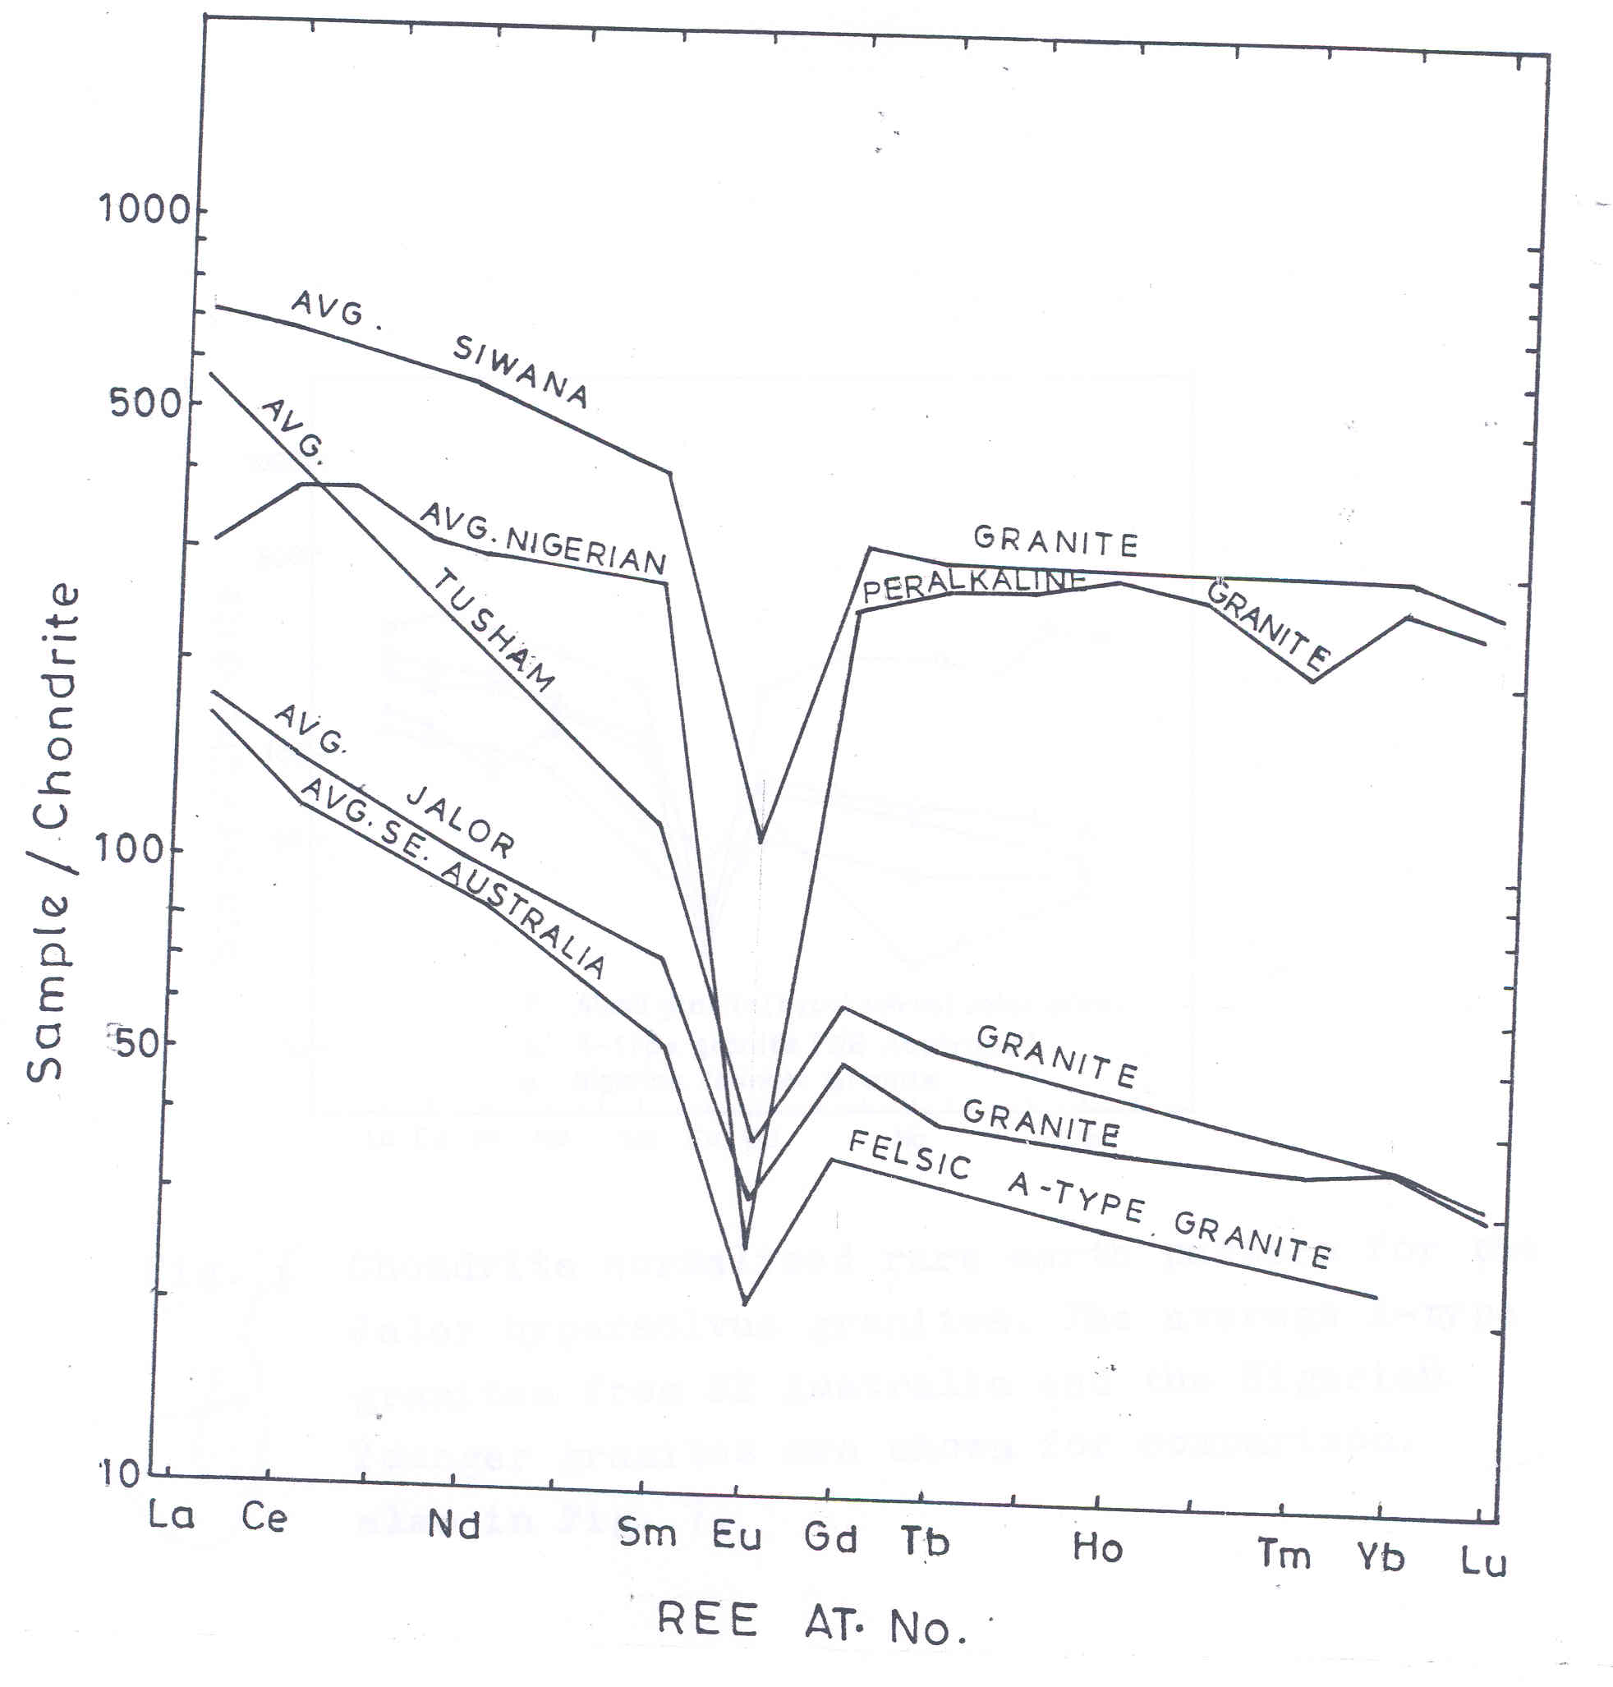
Fig. 6. Chondrite normalized rare earth pattern of the Malani granites compared with the average A-type granites from SE Australia, and the Nigerian peralkaline granites.

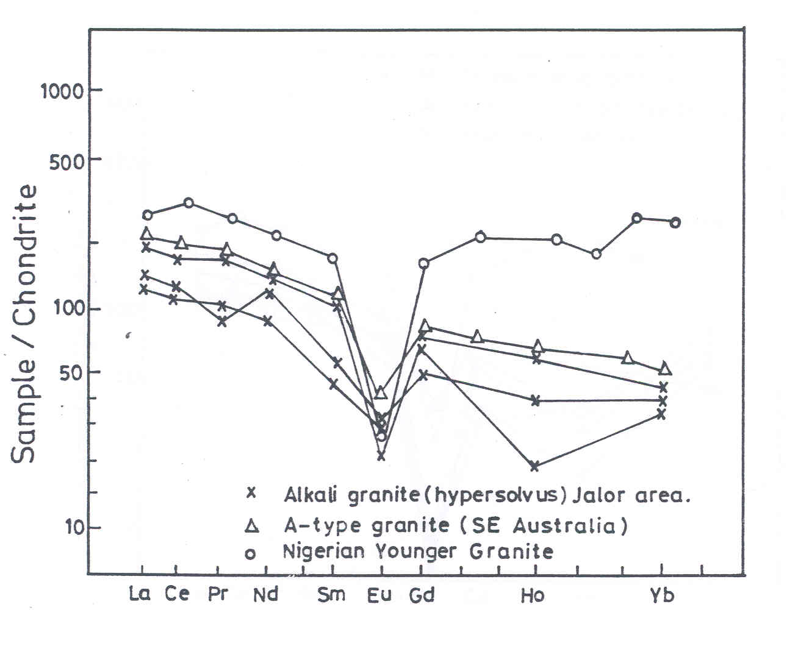
Fig. 7. Chonodrite normalized rare earth pattern for the Jalor hypersolvus granites. The average A-type granites from SE Australia and the Nigerian Younger granites are shown for comparison.
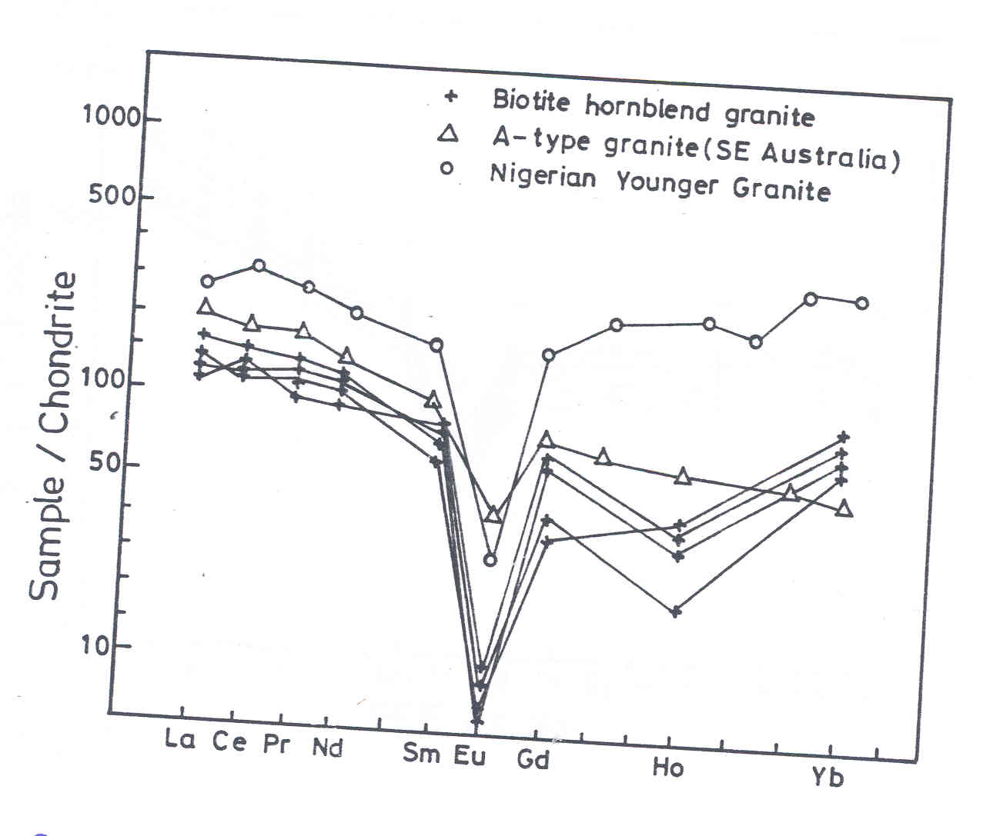
Fig. 8. Chondrite normalized REE plot for the Jalor subsolvus granites.
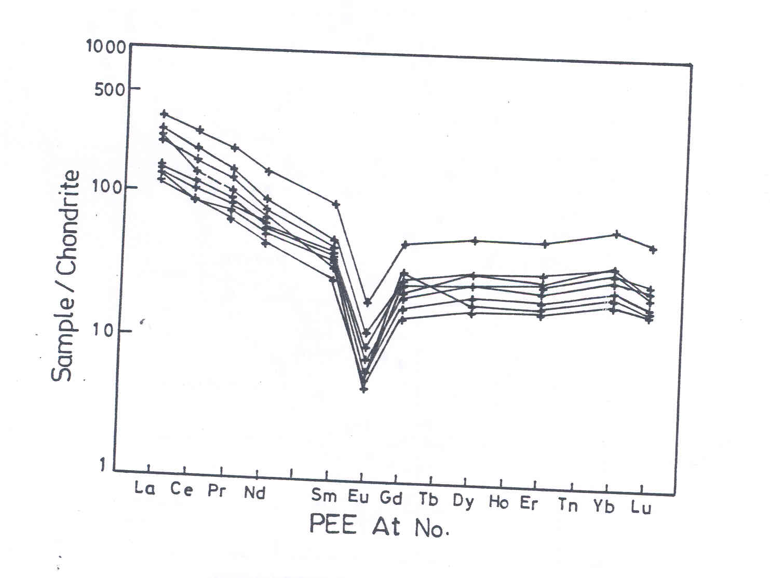
Fig. 9. Chondrite normalized REE plot for the Jhunjhunu alkali feldspar granites.

Fig. 10: ASSEMBLY OF THE MALANI SUPERCONTINENT

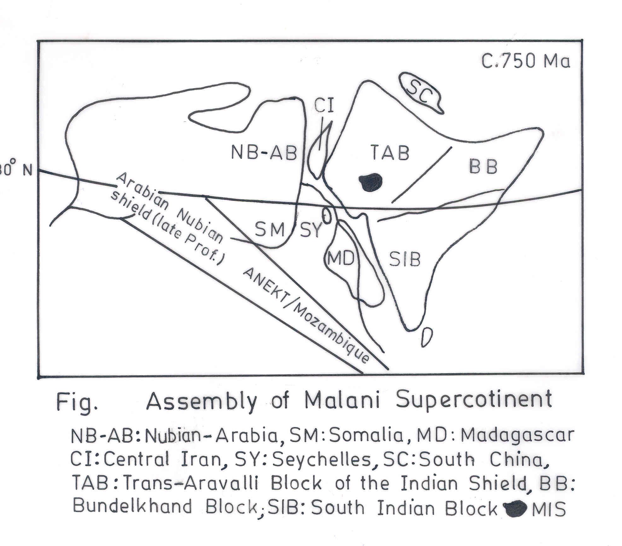

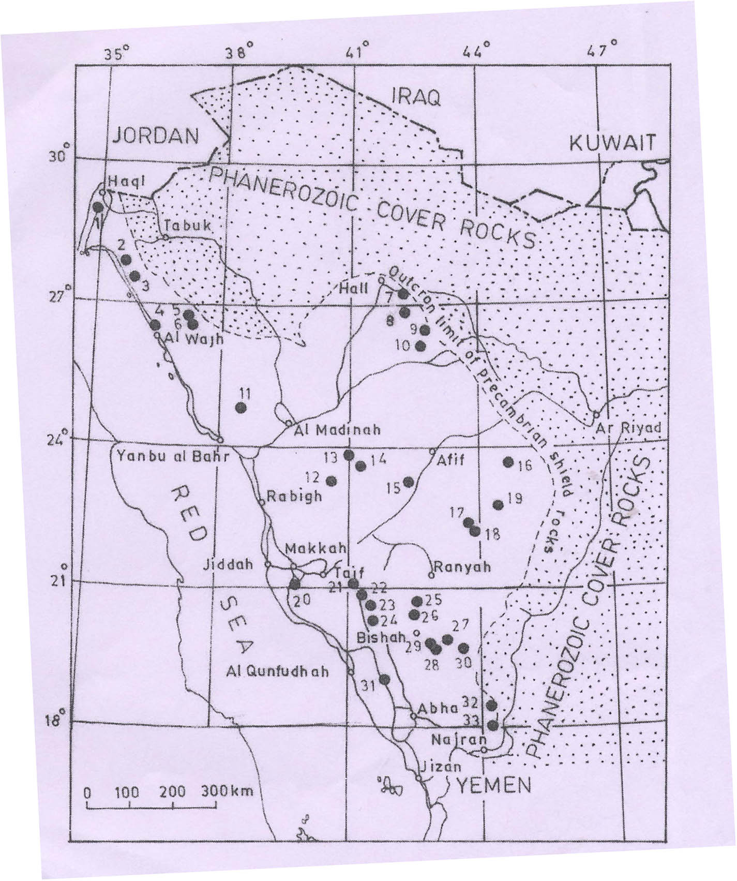

Fig.11 RING STRUCTURES IN THE ARABIAN – NEUBIAN SHIELD :

Table 2 for Fig. 11.

Sr.No. | Location | Type | Geochemical Affinity
1 | Sawda Complex | RC | AA
2 | Dabbagh Complex | RC | AA
3 | Sulay Siyah Complex | RC | P
4 | Liban pluton | BJP | P
5 | Habd Complex | BJP | P
6 | Warid Complex | RC | AA
7 | Jabal Salma Complex | C | AA
8 | Jabal AL-Makhrugah | SR | P
9 | Jabal Raha | C | AA
10 | Jabal Silrilah | SR | AA
11 | Martabah Comples | RC | P
12 | Jabal Ramram | C | P
13 | Jabal Hadash Shara | RC | P
14 | Jabal Hadbad Dayahm | RC | AA
15 | Jabal as Safwah | RC | AA
16 | Jabal Arawan | RC | AA
17 | Jabal Kursh | RC | AA
18 | Jabal Dahul Complex | RC | AA
19 | Uyaijah ring dyke | RC | AA
20 | Unnamed Complex | RC | P
21 | Jabal Al-Qunnah | RC | P
22 | Unnamed ring dyke | SR | AA
23 | Khutamah ring dyke | SR | P
24 | Aquq ring dyke | SR | P
25 | Jabal Munirah | RC | P
26 | Jabal Al Najiah | RC | P
27 | Jabal Bani-Bisqan | RC | AA
28 | Jabal Al-Hasser | RC | AA
29 | Jabal Refdah | RC | P
30 | Unnamed Complex | RC | P
31 | Lakathah Complex | RC | P
32 | Wadi Idimah Complex | RC | AA
33 | Jabal Ashirah Complex | RC | AA

AA : Alkaline affinity, Syenite, alkali granite with Riebeckite, aegirine etc. A-type. P Peraluminous / metaluminous affinity.

Fig. 6

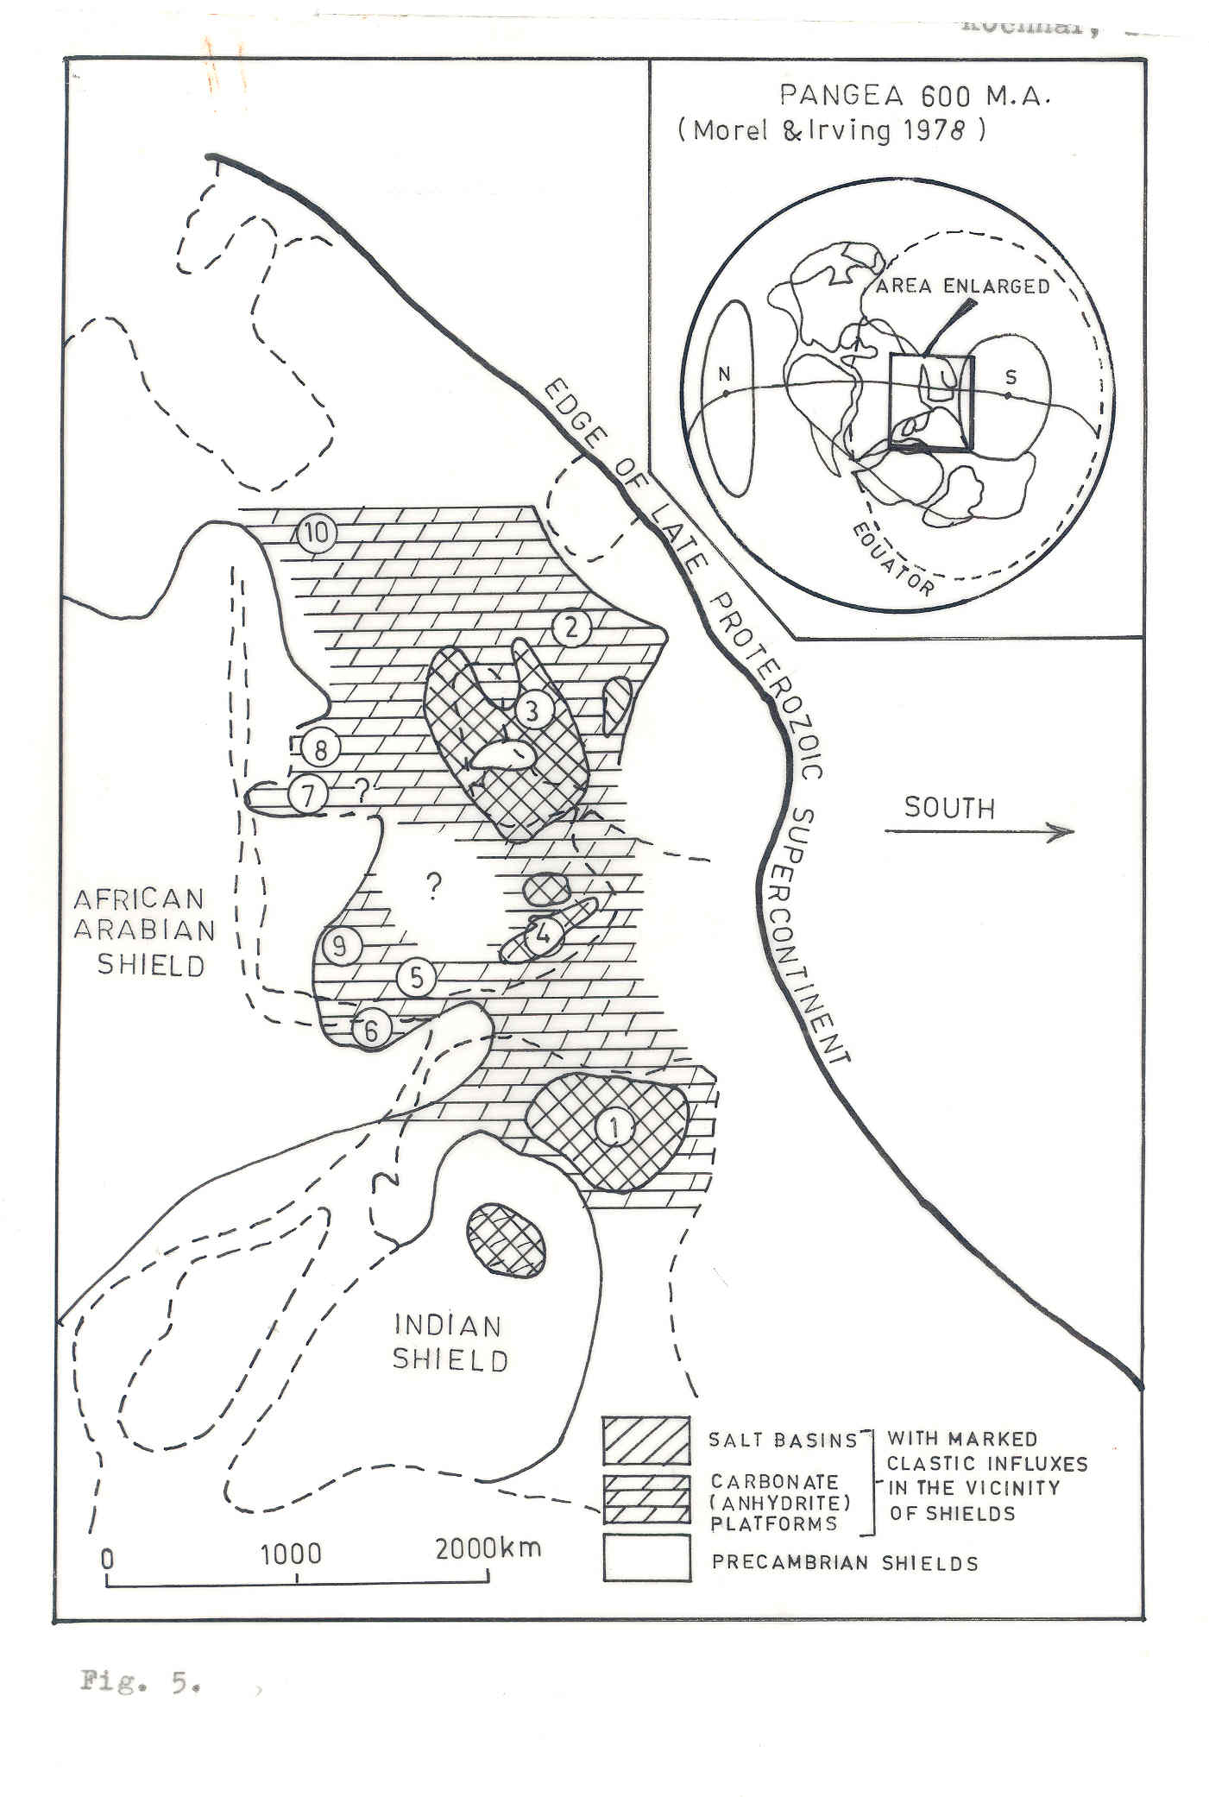

FIG 12: PALEOGEOGRAPHY OF THE LATE PRECAMBRIAN – EARLY CAMBRIAN SEDIMENTS (Gerin et al., AAPG Bull. 66, 1982).

1. Salt Range, Pakistan, 2. Zagros Crush Zone, Central Iran, 3. Harmuz Series, Arabia, 4. Haqf group, Oman, 5. Ghabar group, S. Yeman, 6. Inda Ad Series, Somatra, 7. Wadi Fatima Sena, S. Arabia, 8. Wadi Fatima series, Nougra, S. Arabia, 9. Abla Formation, N. Yeman, 10. Saramuj Formation, Jordan, SW Punjab, Haryana, Rajasthan, NW India.

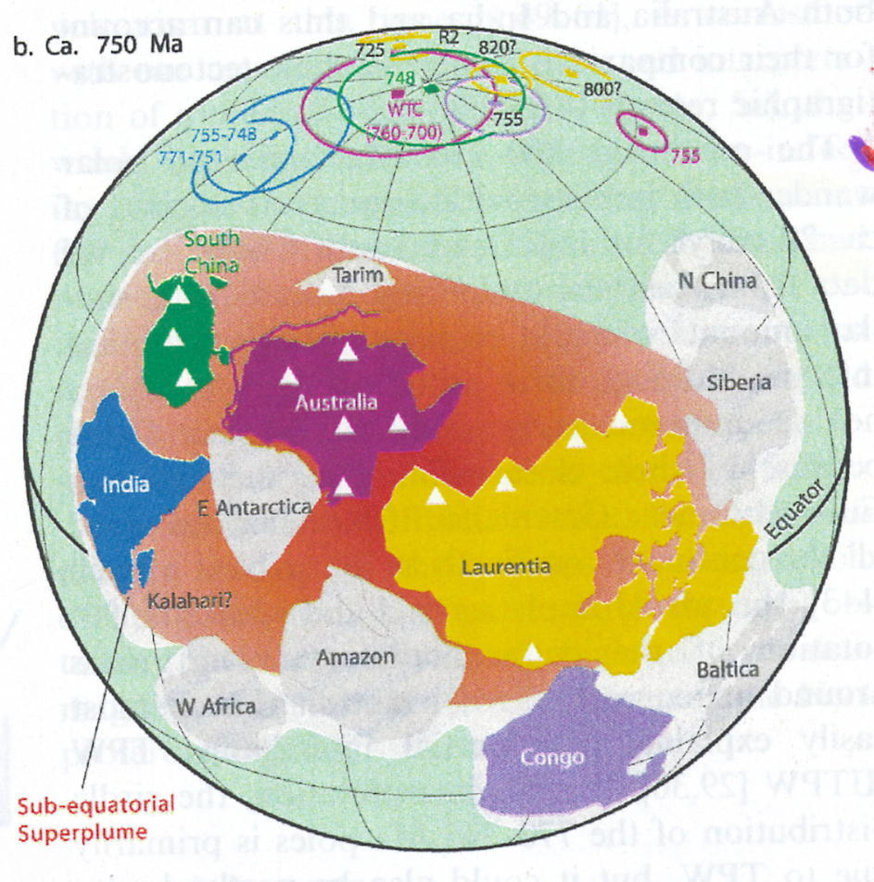
Fig. 13. Paleogeographic reconstrution of Rodinia ‘in tact’ at 750 Ma

